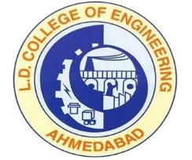 | L.D.College of Engineering,Ahmedabad-380015  एल.डी.कोलेज ऑफ़ इंजीनियरिंग, अहमदाबाद–३८००१५  લા.દ.ઈજનેરી મહાવિદ્યાલય,અમદાવાદ-૩૮૦૦૧૫  Phone:079-26306752 (Office), 26303190  Email: ldce-abad-dte@gujarat.gov.inWebsite: www.ldce.ac.in | 
L.D.C.E./STS/ / Date: - 01/01/2020
Rank Certificate
This is to certify that Mr./Ms………………………………………………. was student of this College and completed his study in this institute in B.E. ………………………………. His Enrollment No. is ……………………... in ……………….
The course is approved by ALL INDIA COUNCIL FOR TECHNICAL EDUCATION, NEW DELHI AND our college is affiliated to the Gujarat Technological University, Chandkheda. The medium of instruction and examination was in English.
He / She was ranked amongst top …… of the batch of ……… students in the ……….. branch throughout all 8 semesters.

Principal
L.D. College of Engineering
Ahmedabad

